

Telegram

Student Preparation:

زياد فهد الطليان

Supervision of Dr:

محمد سعيد محمد عسيري

* Feasibility study

introduction:

Telegram is an instant messaging application that provides free text messaging, voice and video calls, and file sharing services. A feasibility study will be conducted to analyze the financial, operational, economic and technical aspects of the Telegram application.

* Operational feasibility:

Operational feasibility addresses aspects of costs and revenues associated with running an application in the short and medium term. The following is a detailed explanation of the operational feasibility of the Telegram application:

1. Operational costs:

Infrastructure costs: This includes the purchase of servers, application infrastructure, maintenance costs, and subsequent updates.

Development and maintenance costs: These include the costs of developing and updating the application, correcting errors, and improving performance.

Technical support costs: These include the costs of providing a technical support team for users, improving user experience and solving technical problems.

Marketing costs: These include the costs of promoting the application, attracting new users, and increasing the user base.

1. Revenues:

Ads: Telegram can generate revenue through advertisements shown to users. Businesses and advertisers can pay a fee to display their ads within the app.

Paid Subscriptions: Telegram can provide advanced or premium services to users for a monthly or annual subscription fee.

Digital Stores: The Telegram application may provide digital stores where users can purchase products and services through the application and generate revenue from sales commissions.

Operational feasibility also needs to identify potential barriers that could affect the operation, marketing and profitability process, analyze them and find effective solutions. These potential barriers may include competition from other applications, privacy and security issues, changing user behavior, and others.

|  |  |
| --- | --- |
| Financial Assumptions | Operational Terms |
| $100,000 | Infrastructure Costs |
| $50,000 | Development and Maintenance Costs |
| $20,000 | Technical Support Costs |
| $30,000 | Marketing Costs |
| $200,000 | Total Operating Costs |

conclusion:

After analyzing the operational feasibility of the Telegram application, the expected revenues are estimated and the expected costs are determined.

The total revenue must be greater than the total costs to make the project profitable. Operational feasibility should be regularly evaluated and updated to track application performance and take measures to improve return on investment.

Note: A comprehensive analysis of the financial, marketing, technical and legal aspects must be carried out before making any investment decision or developing an application such as Telegram.

This answer provides general information and is not a substitute for an in-depth feasibility study.

* Technical feasibility

Technical feasibility looks at the technology aspects associated with Telegram. They include a detailed analysis of the technical and infrastructure requirements and costs involved in developing and maintaining the application. Below is a detailed explanation of the technical feasibility and an ordered table of costs with hypothetical values:

1. Technical requirements:

Operating System: Telegram requires support for various operating systems such as iOS, Android, and Windows.

Database: Telegram needs a strong database to store sensitive information of users and messages.

Information Security: The application must provide a strong system for protecting personal data, encrypting messages, and securing communications.

Fast Responsiveness: Telegram requires fast performance to provide a smooth user experience, regardless of the size of the user base.

1. Technical Infrastructure:

Servers and Networks: Telegram requires a strong infrastructure of servers and networks to handle a large volume of users and facilitate communication and sharing.

Updates and development: Resources must be allocated to update and develop the application periodically to meet the needs of users and keep abreast of technical developments.

1. Technical costs:

|  |  |
| --- | --- |
| Financial Assumptions | Technical items |
| $150,000 | Application Development Costs |
| $50,000 | Server Purchase and Maintenance Costs |
| $30,000 | Security and Encryption Costs |
| $230,000 | Total Technical Costs |

* Economic Feasibility

Economic feasibility is an important aspect of analyzing the Telegram application, as it addresses the financial and economic aspects associated with operating the application and evaluating its long-term profitability. The following is a detailed explanation of the economic feasibility:

1. Capital costs:

These costs include the initial investments required to develop and launch the Telegram application. Capital costs may include the purchase of hardware, software, and infrastructure, costs of hiring the technical and marketing staff, and any other costs associated with start-up.

1. Operational costs:

Operational costs include the routine expenses that have to be incurred to ensure the continued operation of the application. Operational costs include employee wages, technical support costs, marketing and advertising costs, infrastructure and maintenance costs, hosting and server costs, and any other costs related to the day-to-day operational process.

1. Revenue:

Revenue includes the financial sources an app can earn. Revenue may include user advertisements, subscription fees, and sales revenue from in-app digital stores.

1. Estimating Profitability:

Profitability estimate is calculated by comparing expected revenue with operating costs. If revenues exceed costs, this indicates that the app is making money. Time factors and long-term ROI estimation must also be considered.

1. Sensitivity Analysis:

A sensitivity analysis can be performed to estimate the potential effects of changes in key factors such as revenue and costs on bottom line profitability. Sensitivity analysis can help identify areas that can be improved to achieve the best financial results.

* Project requirements:

There are a number of technical and functional requirements that must be considered. The following is a detailed explanation of the main requirements for the work of the Telegram application:

1. User Interface Design (UI):

The application should be easy to use, have an attractive design and a flexible user interface. It should include simple and clear interface elements that make it easy to navigate and interact with the application.

1. Search for users and groups

The application must provide a mechanism to search for users and groups.

1. Registration and Authentication:

The application shall provide a mechanism for registering users and verifying their identity. This can include your email, phone number, or login through social networking accounts.

1. Messaging and chatting:

The application must provide the functionality of instant messaging and chatting between users. Users must be able to send text and multimedia messages such as photos, videos, and files.

1. Channels and groups:

The application shall enable the creation of channels and groups for users to communicate and share content. These channels and groups should be publicly or privately viewable depending on preference.

1. Security and privacy:

The application must provide strong security features to protect users' personal data and encrypt messages. There should be options to control the privacy settings and the level of access to the content.

1. Application Notices:

The app must have an effective notification system that allows users to receive alerts about new messages or other activity within the app.

1. Data Sync:

The app should allow data to sync between different users' devices, allowing them to access conversations and files from any device.

1. Multiple languages ​​support:

The application must be able to support multiple languages ​​to provide a satisfactory experience for users of different cultures and languages.

1. Data Storage and Hosting:

The application needs a strong database to store users, messages and other content. Storage and hosting should be well secured to protect data.

1. Compatibility with different systems:

The application must be compatible with different operating systems such as iOS, Android, Windows, etc.

**UML Daigram**

1. Activity Daigram:

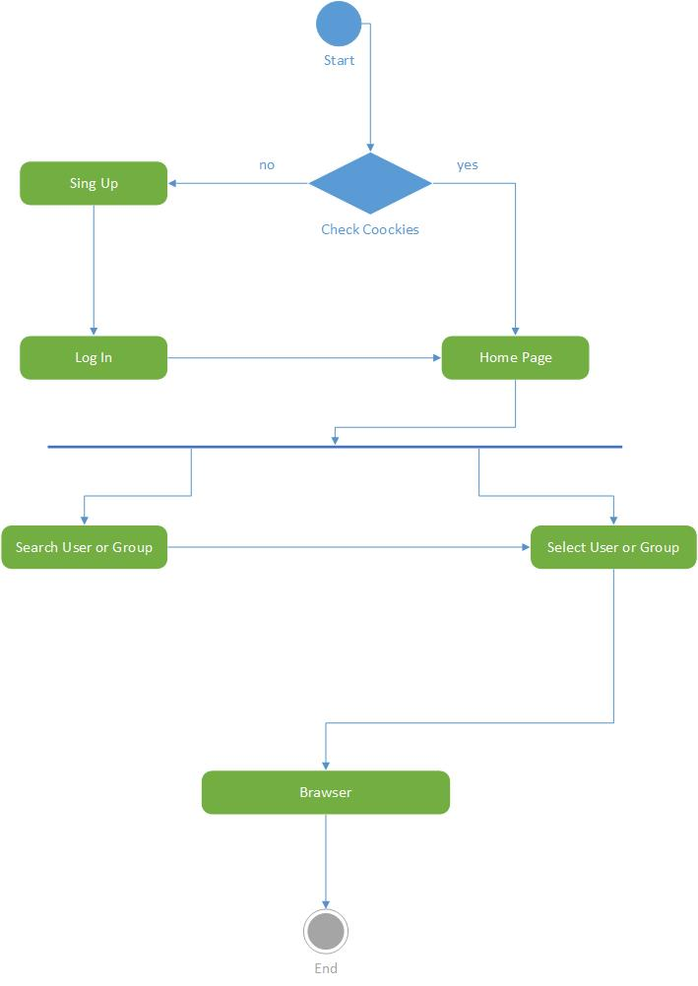

1. Sequence Daigram: Scenario
2. The user opens the Telegram application on their mobile phone and navigates to the search screen.
3. The search interface appears, allowing the user to input search keywords.
4. The user enters the desired search keywords, such as a username, group name, or channel name.
5. When the user presses the "Search" button, a search request is sent to the Telegram server.
6. The server receives the search request and starts analyzing the entered keywords.
7. The keywords are analyzed to determine the type of object the user is searching for, whether it is a user, group, or channel.
8. The server executes the search operation and queries the database to find matching objects based on the keywords.
9. The matching results are sent back to the application.
10. The application receives the results and displays them in the user interface.
11. The user can filter the results or select the object they wish to interact with, such as joining a group or subscribing to a channel.

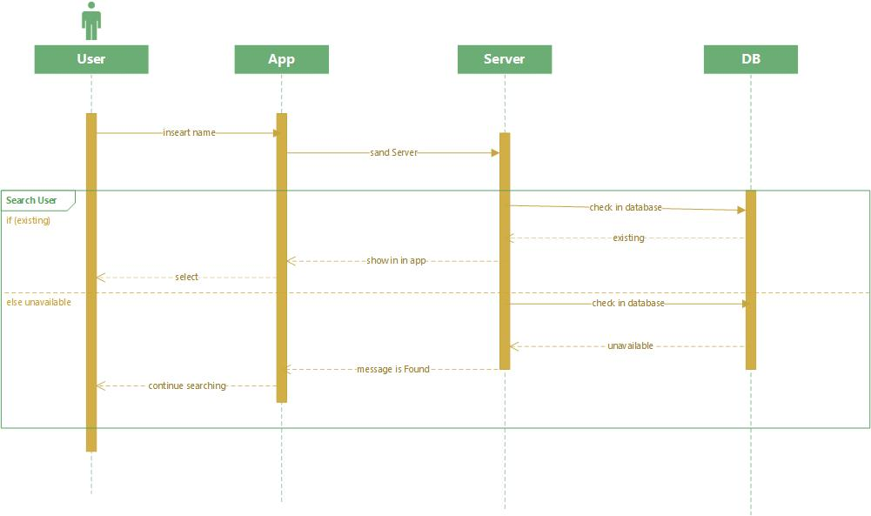

1. Use Case Modelling

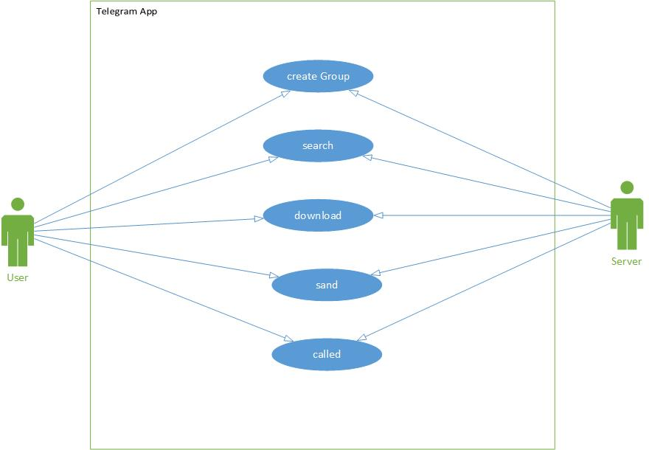

* system interfaces:

1. Web Application:

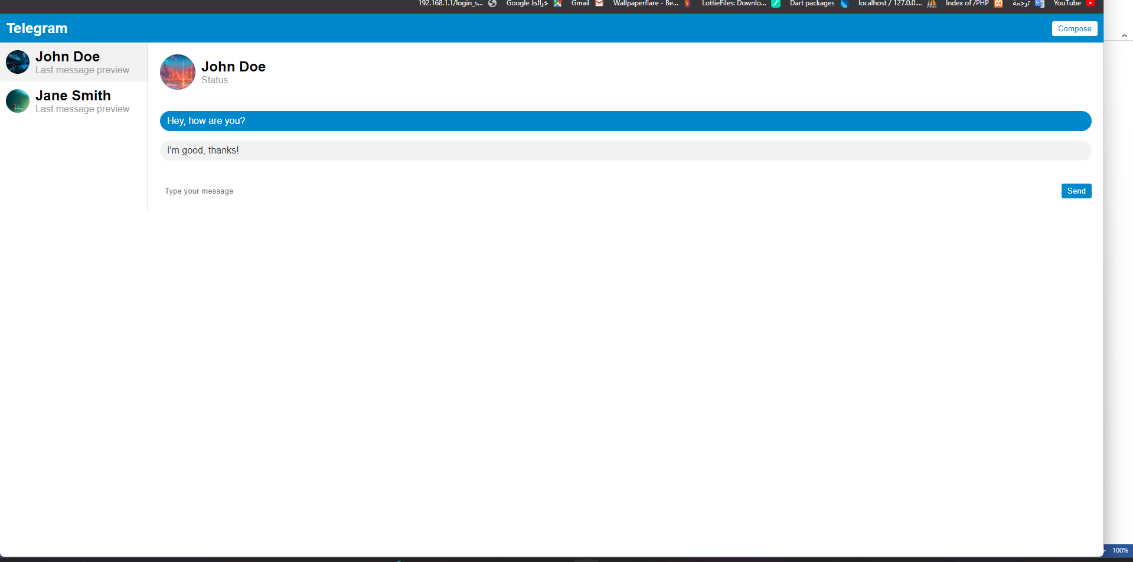

1. Mobile Application:

